ASSIGNMENT 4.1 AIAC
2303A51015(SRIKARAN)-BATCH-01
Q1. Zero-Shot Prompting (Basic Lab Task)
Task:
Write a Python function that classifies a given text as Spam or Not
Spam using zero-shot prompting.
Steps:
1. Construct a prompt without any examples.
2. Clearly specify the output labels.
3. Display only the predicted label.
Input:
"Congratulations! You have won a free lottery ticket."
Expected Output:
Spam
#prompt
'''
write a python code to check whearther the text is spam or not spam
n=""Congratulations! You have won a free lottery ticket."
display as spam
'''
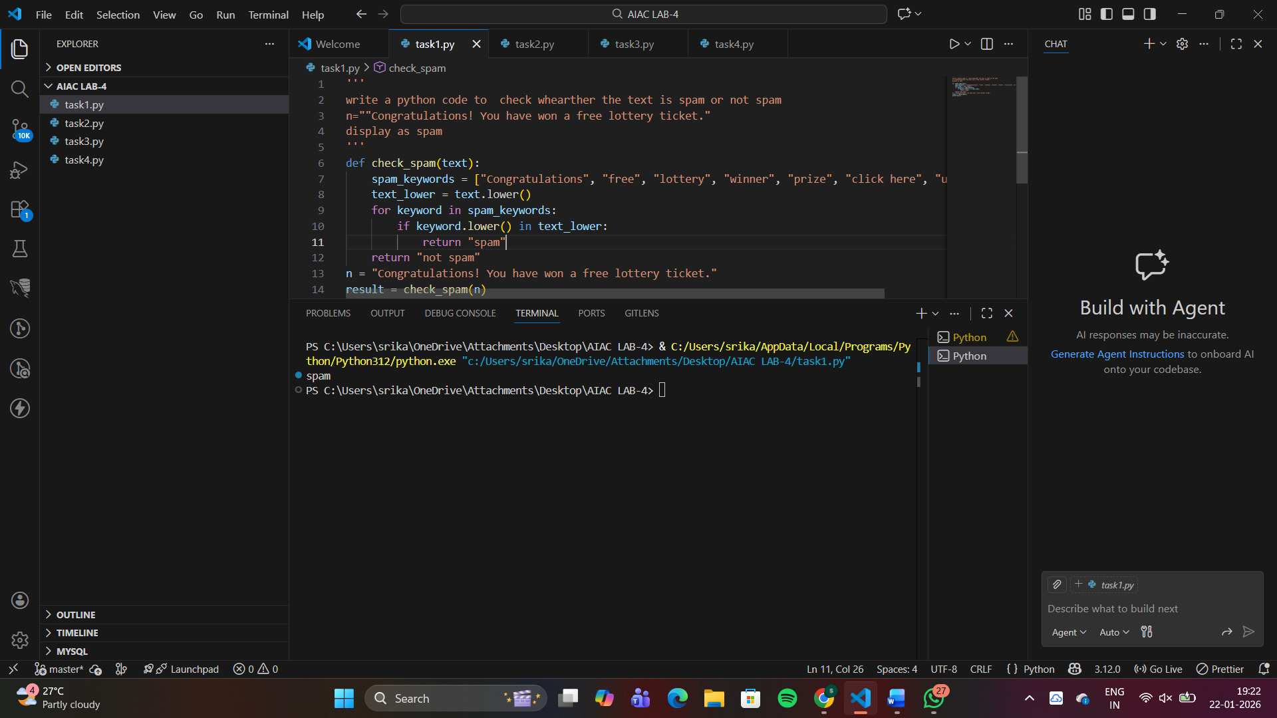
Q2. One-Shot Prompting (Emotion detection)
Task:
Write a Python program that detects the emotion of a sentence
using one-shot prompting.
Emotions: [‘happy', 'sad', 'angry', 'excited', 'nervous', ’neutral’]
Steps:
1. Provide one labeled example inside the prompt.
2. Take a sentence as input.
3. Print the predicted emotion
#prompt
'''
generate a python code if it contains emotioms as['happy', 'sad', 'angry', 'excited','nervous','neutral']
input write any sentence and the code will identify the emotion from the list and print it out.
'''

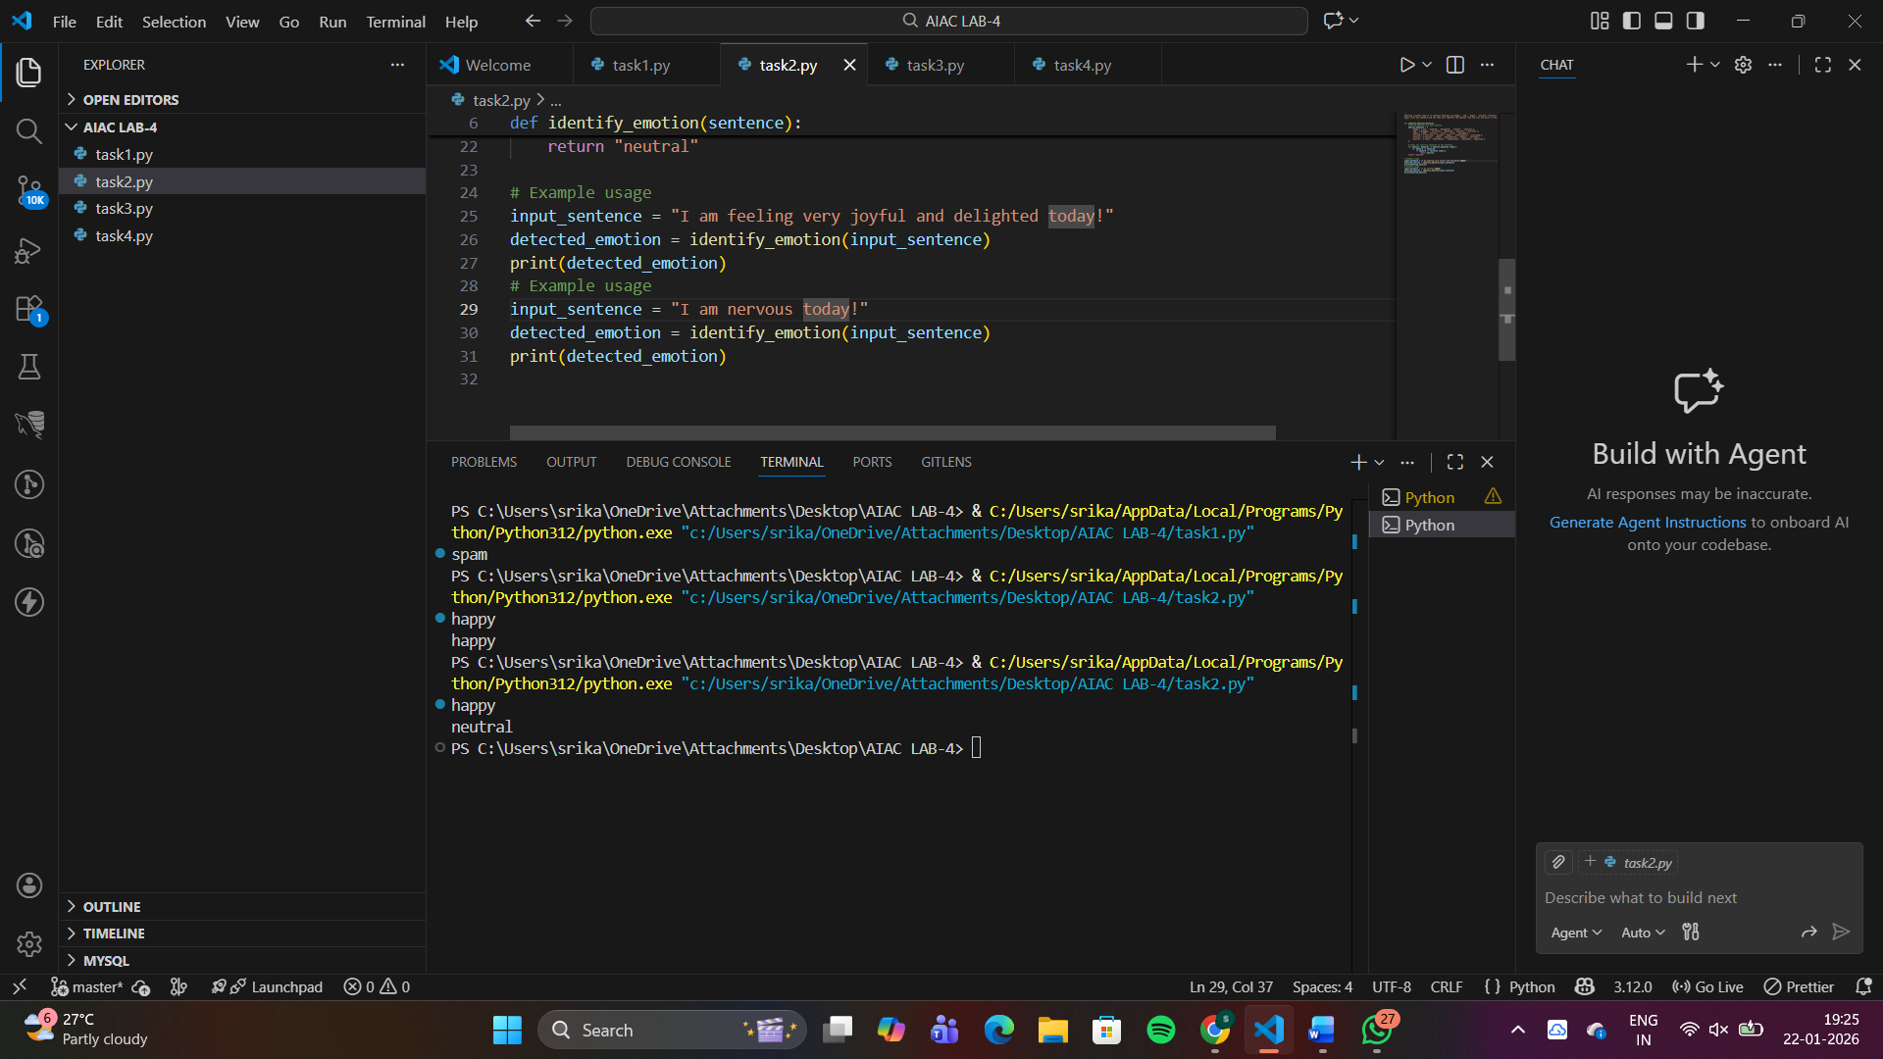
Q3. Few-Shot Prompting (Student Grading Based on Marks)
Task:
Write a Python program that predicts a student’s grade based on
marks using few-shot prompting.
Grades:
['A', 'B', 'C', 'D', 'F']
Grading Criteria (to be inferred from examples):
• 90–100 → A
• 80–89 → B
• 70–79 → C
• 60–69 → D
• Below 60 → F
#prompt
'''
90 to 100
display grade as 'A'
80 to 89
display grade as 'B'
70 to 79
display grade as 'C'
60 to 69
display grade as 'D'
Below 60
display grade as 'F'
'''
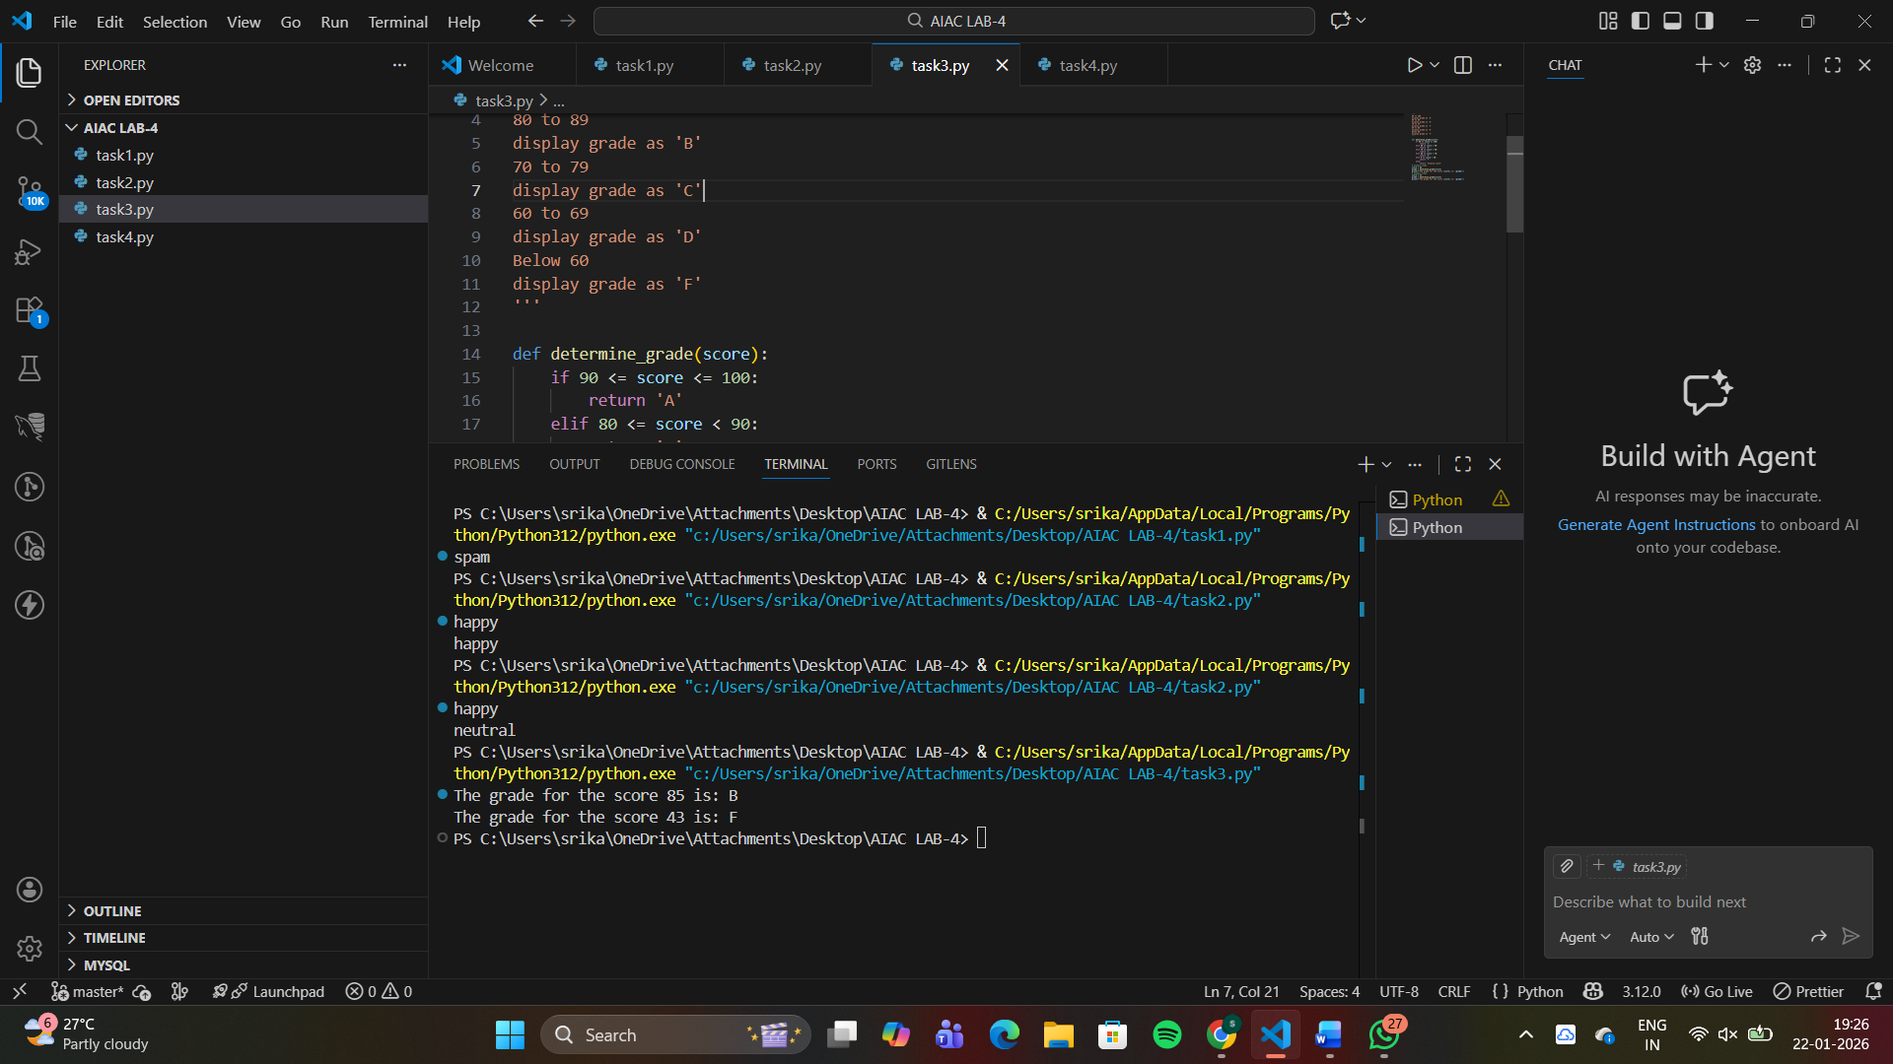
Q4. Multi-Shot Prompting (Indian Zodiac Sign Prediction using
Month Name)
Task:
Write a Python program that predicts a person’s Indian Zodiac sign
(Rashi) based on the month of birth (month name) using multi-shot
prompting.
Indian Zodiac Order (Simplified Month-Based Model): The Indian
Zodiac cycle starts in March with Mesha and follows this order:
March → Mesha
April → Vrishabha
May → Mithuna
June → Karka
July → Simha
August → Kanya
September → Tula
October → Vrischika
November → Dhanu
December → Makara
January → Kumbha
February → Meena
#prompt
'''
indian Zodiac Order
March → Mesha
April → Vrishabha
May → Mithuna
June → Karka
July → Simha
August → Kanya
September → Tula
October → Vrischika
November → Dhanu
December → Makara
January → Kumbha
February → Meena
diaply the zodiac sign based on the month input by the user.
'''
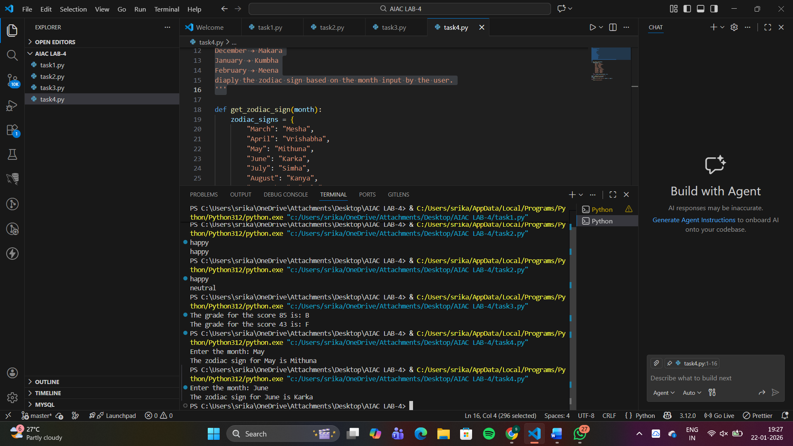
Q5. Result Analysis Based on Marks
Task: Write a Python program that determines whether a student
Passes or Fails based on marks using Chain-of-Thought (CoT)
prompting.
Result Categories:
['Pass', 'Fail']
#promt
'''
read the students marks as input.
validate the marks to be between 0 and 100.
students with marks greater than or equal to 40 are considered pass, otherwise fail.
'''
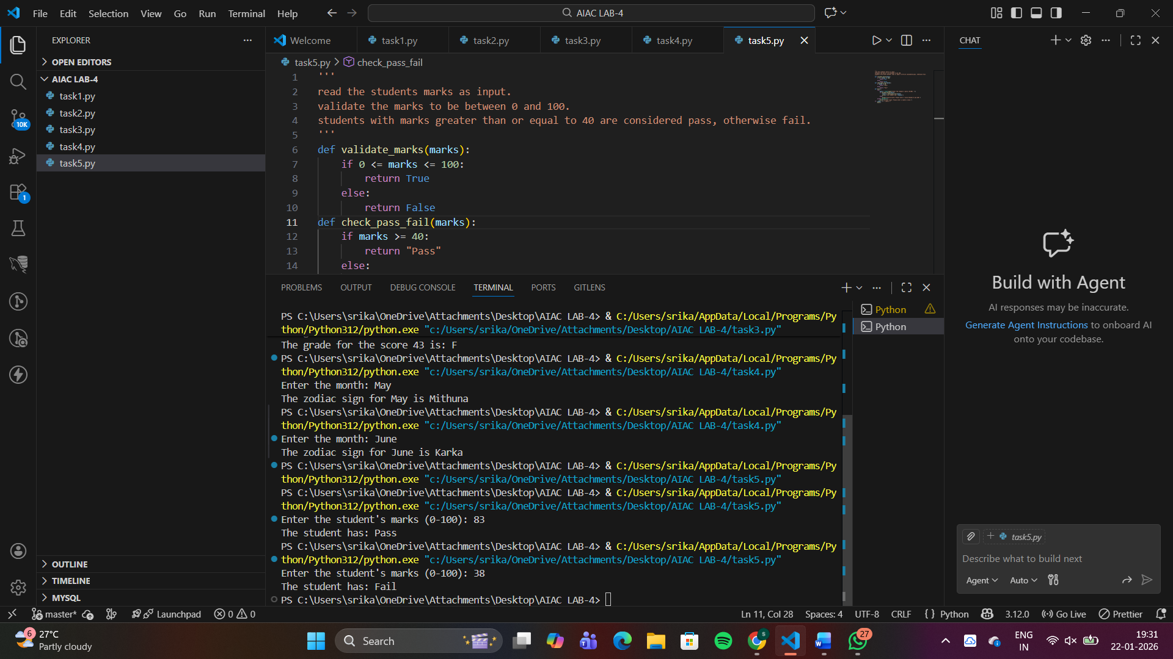
Q6 Voting Eligibility Check (Chain-of-Thought Prompting)
Task: Write a Python program that determines whether a person is
eligible to vote using Chain-of-Thought (CoT) prompting.
#prompt
'''
read persons age.
if he above 18 then he is eligible to vote.
if he is below 18 then he is not eligible to vote.
'''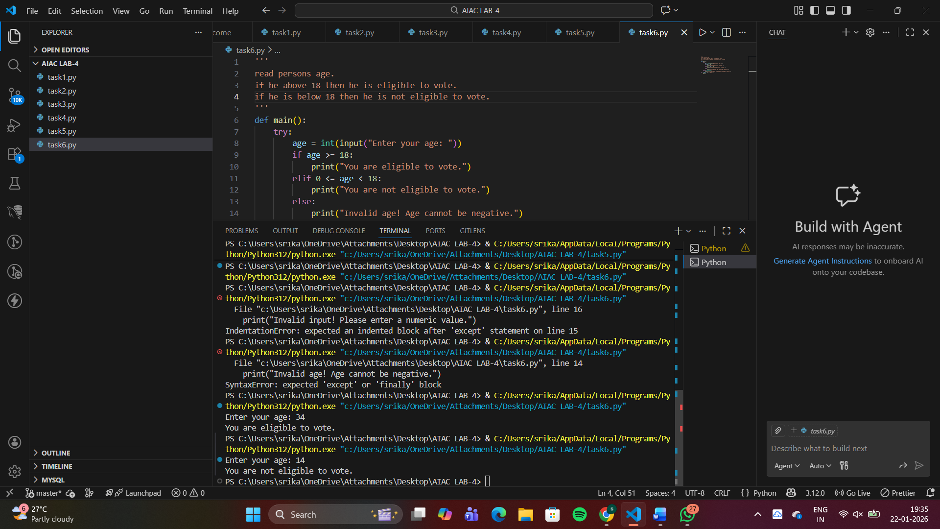
Q7 Prompt Chaining (String Processing – Palindrome Names)
Task: Write a Python program that uses the prompt chaining
technique to identify palindrome names from a list of student
names
#prompt
'''
generate a list of student names and store it in a variable.
traverse the list and reverse each name using a loop.
if the reversed name is the same as the original name, print that the name is a palindrome.
otherwise, print that it is not a palindrome.
'''
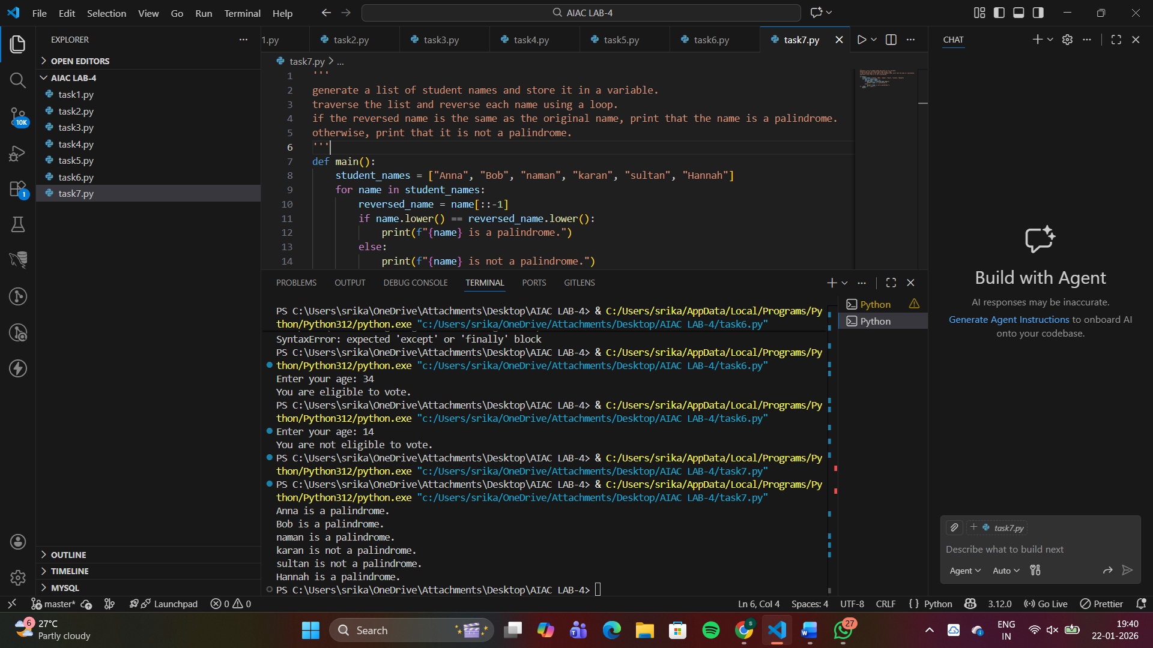
Q8 Prompt Chaining (String Processing – Word Length
Analysis)
Task: Write a Python program that uses prompt chaining to
analyze a list of words. In the first prompt, generate a list of words.
In the second prompt, traverse the list and calculate the length of
each word. In the third prompt, use the output of the previous step
to determine whether each word is Short (length less than 5) or
Long (length greater than or equal to 5), and display the result for
each word
#prompt
'''
Generate a list of words related to daily activities
Using the list of words, calculate the length of each word.
Using the word lengths, classify each word as Short (length < 5) or Long (length ≥ 5) and display the results.
'''
